Recording Remotely (AINC Volunteer Portal Instructions)

Before you start, make sure:
- You have your reading materials or online page loaded
- You have your portal login name, and password
- You have your program code
- Your microphone is plugged in, and turned on
- You are in quiet area.

- Go to aincolorado.org
- Click on Volunteer at the top of the banner:
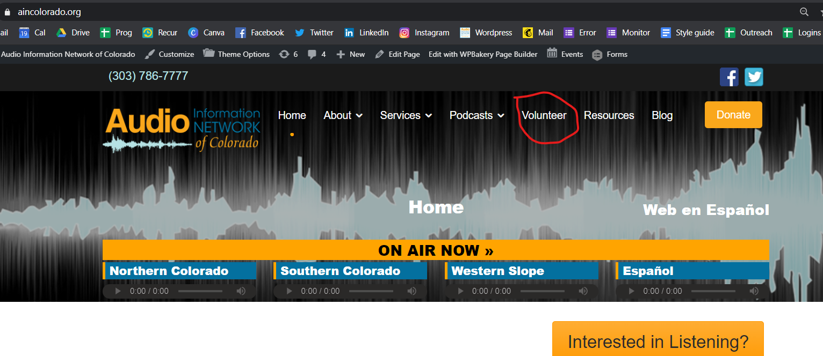
- Click Volunteer Portal
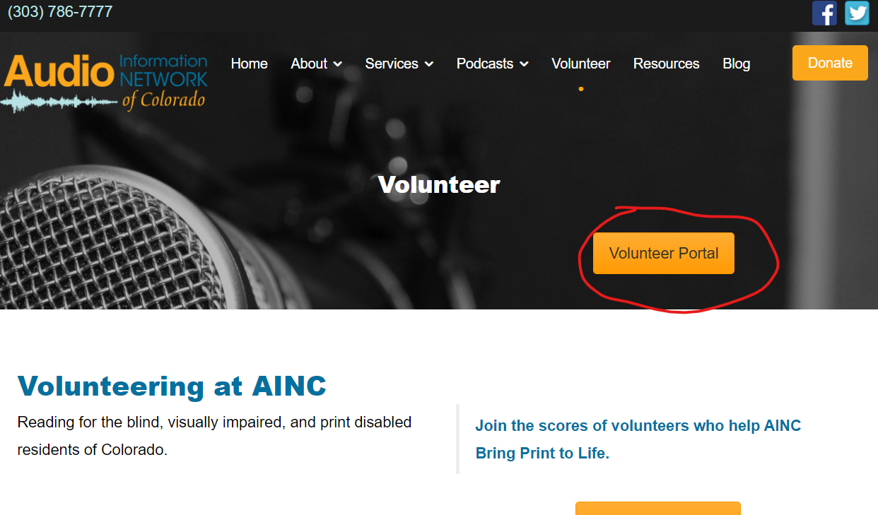
- You will be prompted for a password: The password is: volunteer
PLEASE NOTE THERE ARE 2 LEVELS OF PASSWORDS! IT WILL NOT LOG YOU IN IF YOU PUT YOUR PERSONAL FILE SERVER PASSWORD ON THIS STEP
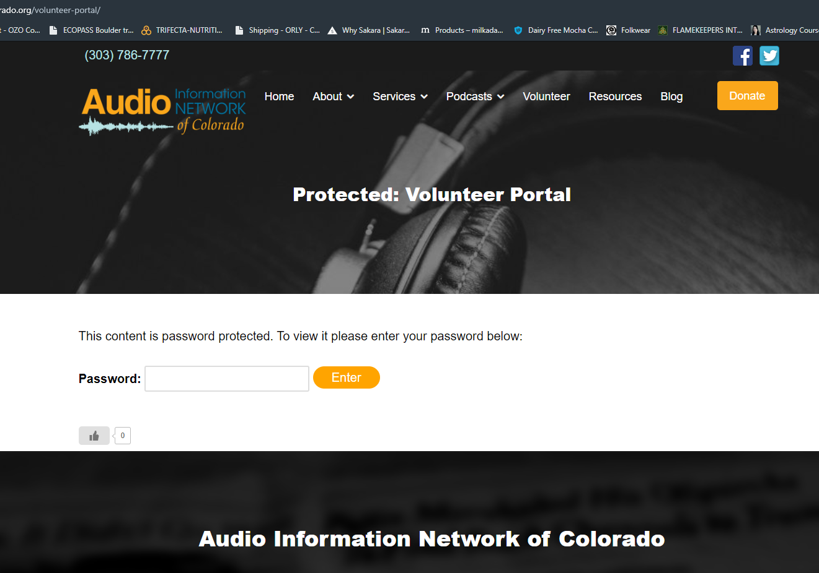
- Click enter, and you will be taken to your to your dashboard. Here, you can access the forum, recording software, and most importantly, the file portal (Volunteer Reader Portal) you will use to submit your file.
- Before you log into the Volunteer Reader Portal, you will record your program. On the left side of the screen you will see the record button. Right click it and select “open in a new tab” and click the opened tab on the top of the browser.
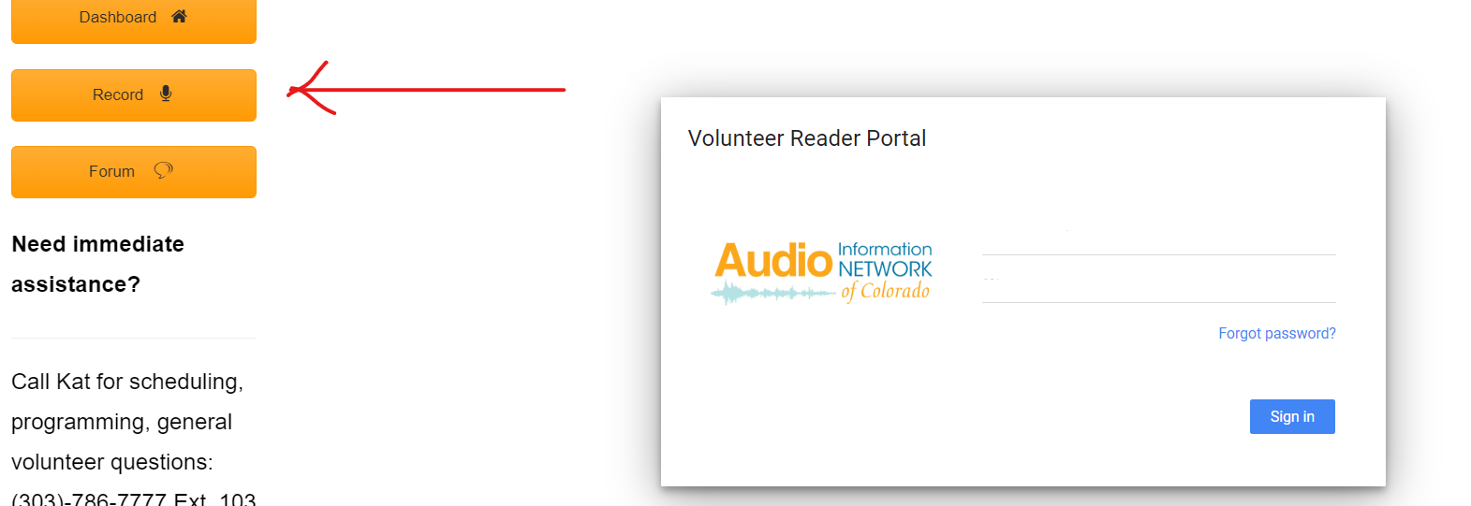
- Click record, and a popup will show asking for permission to use your microphone. IMPORTANT: VARIOUS ADS WILL DISPLAY JUST BELOW THE RECORD BUTTONS IN THE LIGHT GRAY RECTANGLE SAYING “DOWNLOAD NOW” OR “OPEN” OR OTHER VARATIONS. THESE ARE ADVERTISEMENTS - DO NOT OPEN!
- Click allow (see below)

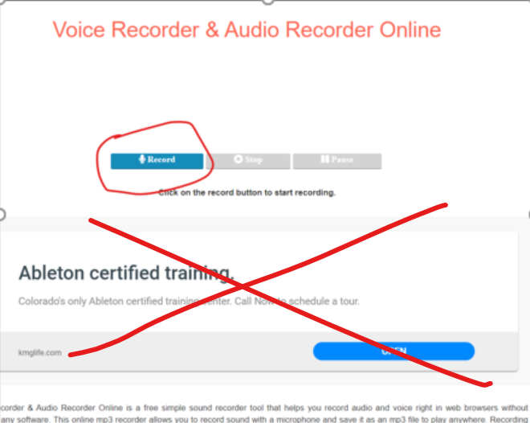
IGNORE AD!
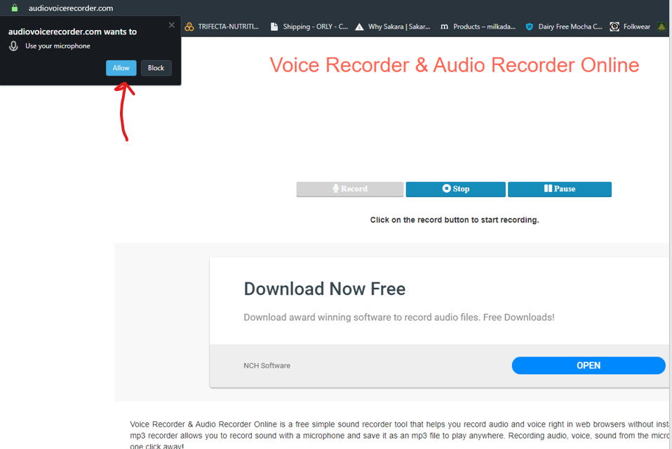
- If all went well, you will see an audio wave moving on the top of the screen. The audio wave will only move when you begin talking.
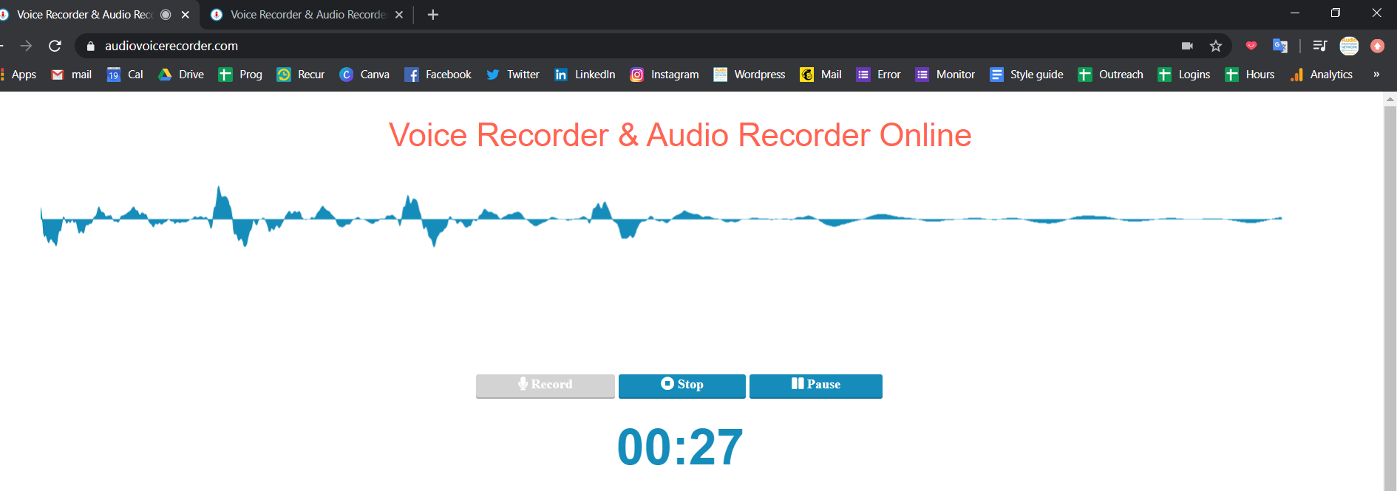
- You are now being recorded. To throw out this take, click “Stop” and then “Record another”. This will bring up a pop-up menu.
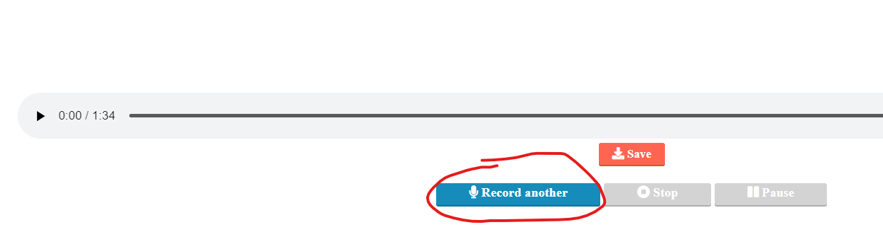
- On the pop-up menu, click “Yes, do another recording” when you are ready to record. It will start recording immediately.
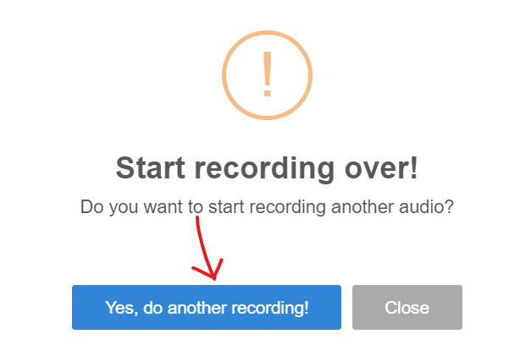

NOTE: Use RECORD to record, PAUSE to pause during the recording, and STOP when you are finished. You will not be able to back up and correct mistakes using this record program, so if you use another program that you like that lets you save your file as an MP3, then go ahead and use it. You will be able to upload your file to the portal when you are ready.

- Once you click the stop key select save. You will see a pop-up menu from your browser asking what you want to do with this file. Select Save to save to your downloads folder on your device.
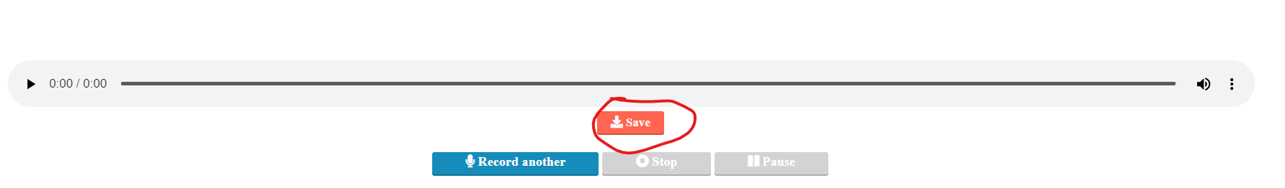

- Return to the Volunteer Portal.
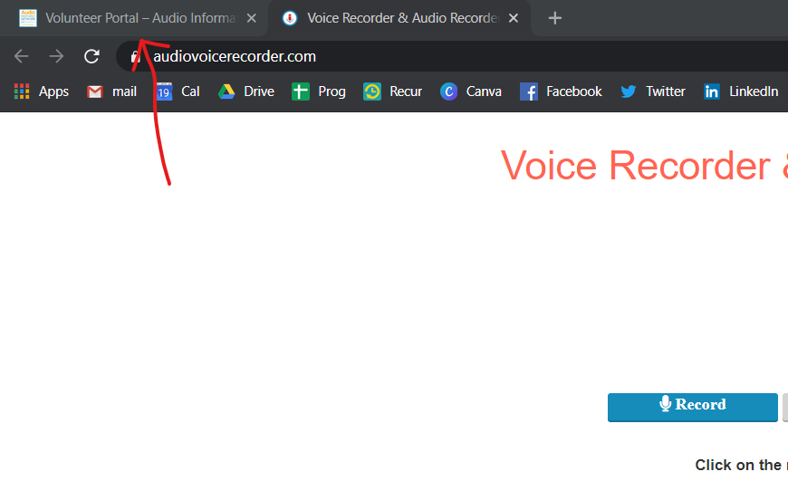
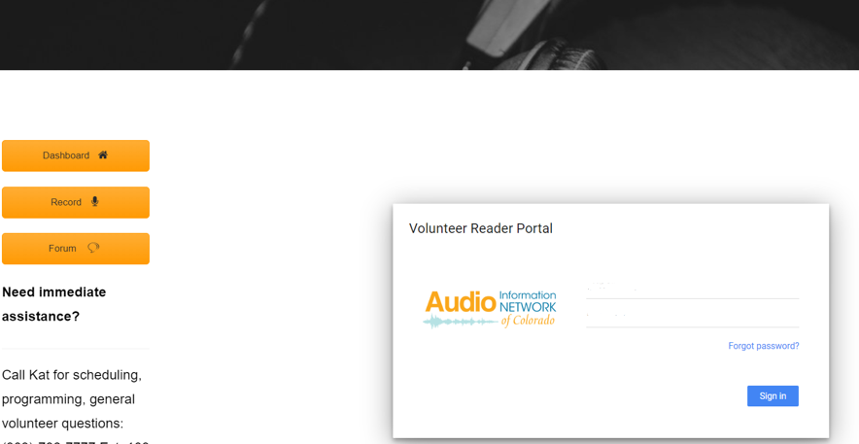
- Log into the Volunteer Reader Portal to submit your file. Enter your username and password into the “Volunteer Reader Portal” box. Click on the “+ New”’ button and a drop down menu appears (see below).

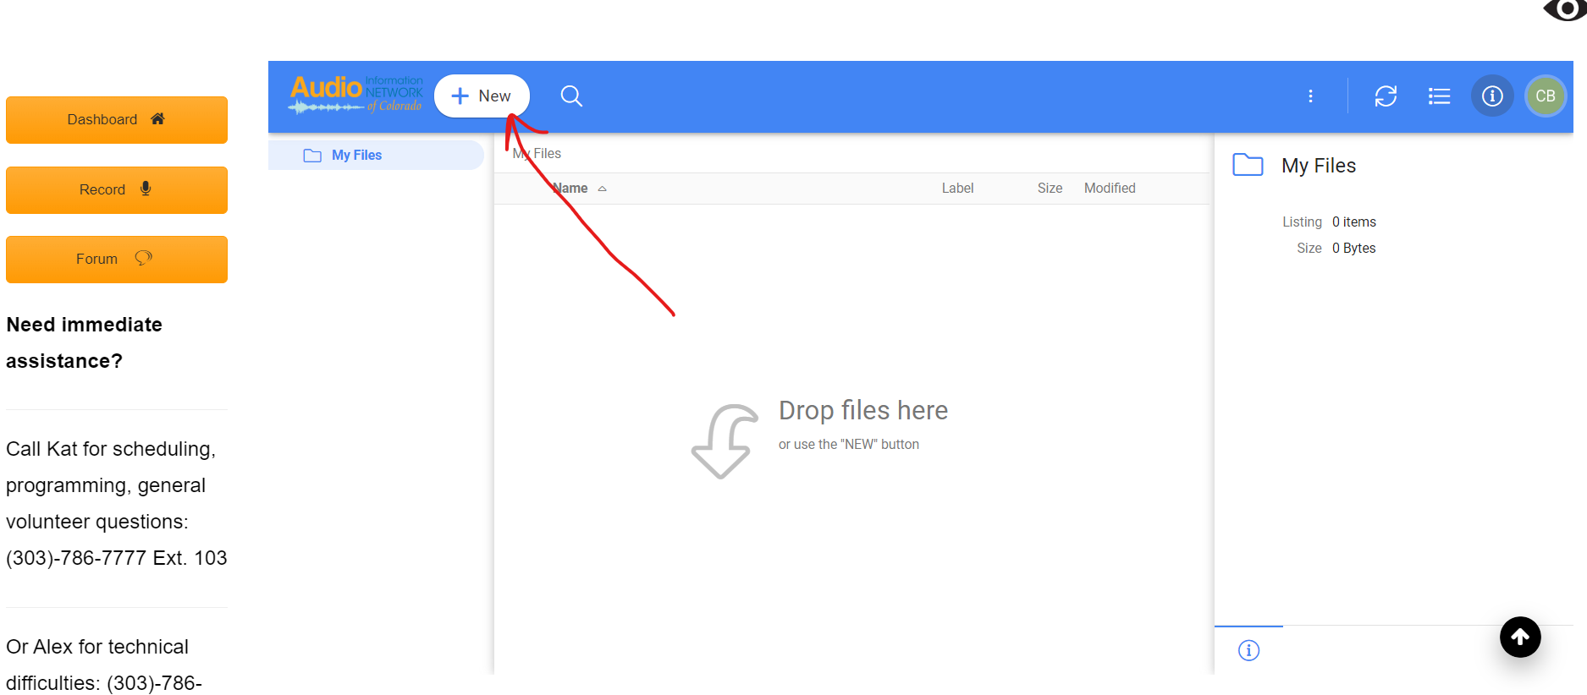

- Choose “file upload” and it will take you back to your computer’s downloads folder.
  - If you are not on the page where your new file is, go to downloads folder.
- IMPORTANT: Change the the name of your file to your specified program code. See highlighted file below. It will likely be numbered one most recently modified in your downloads folder.
- Right click your file, and a drop down menu appears (see below). Choose rename and type in your program code. It must be in all lower cases, no numbers, no spaces, no volunteer names, or dates (Example: went.mp3). If you do not know the code of your program, contact Kat or Alex.

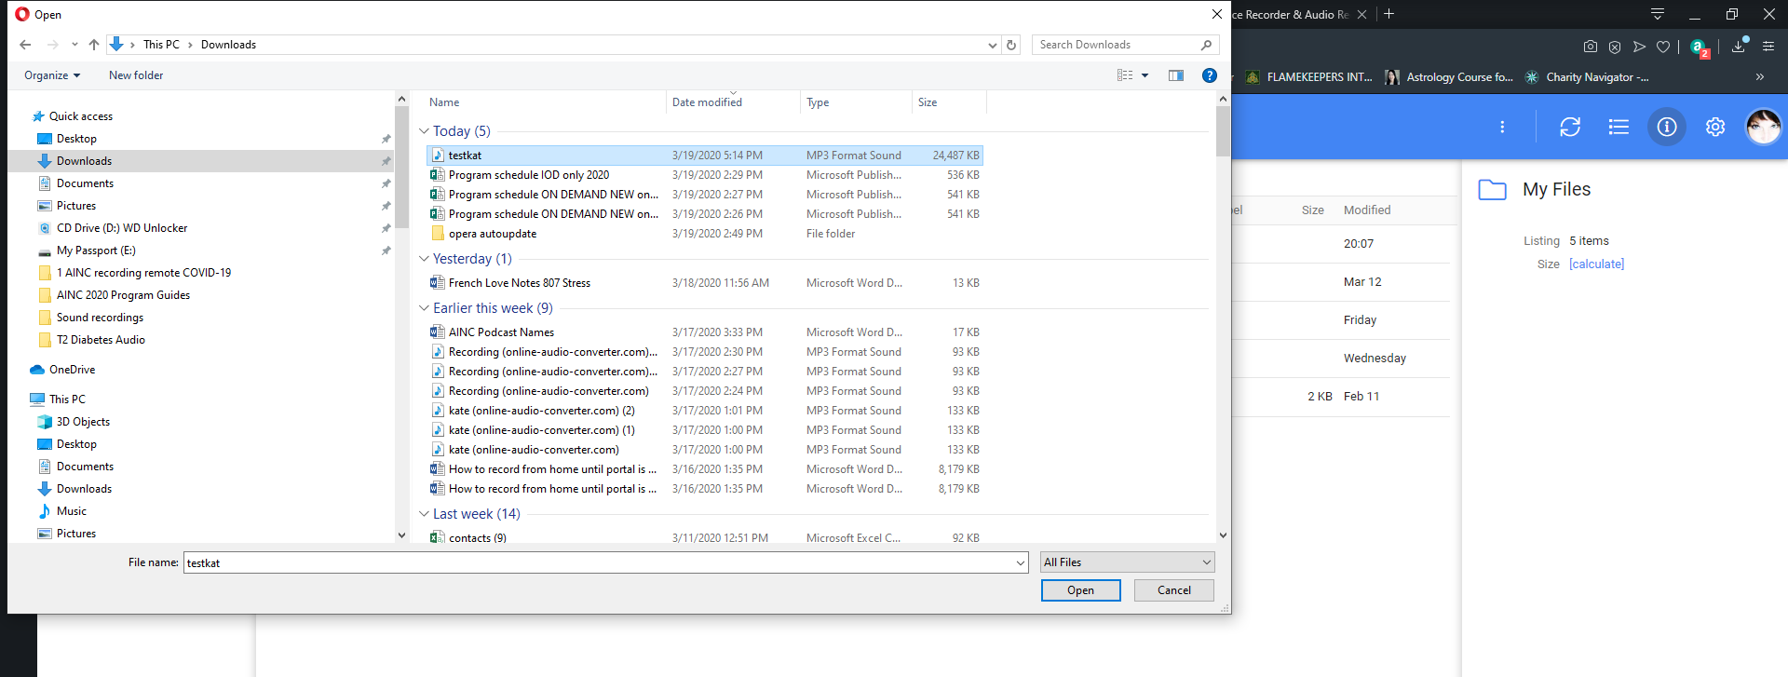
- Highlight your file and click open. You file will now upload to your portal (see below)
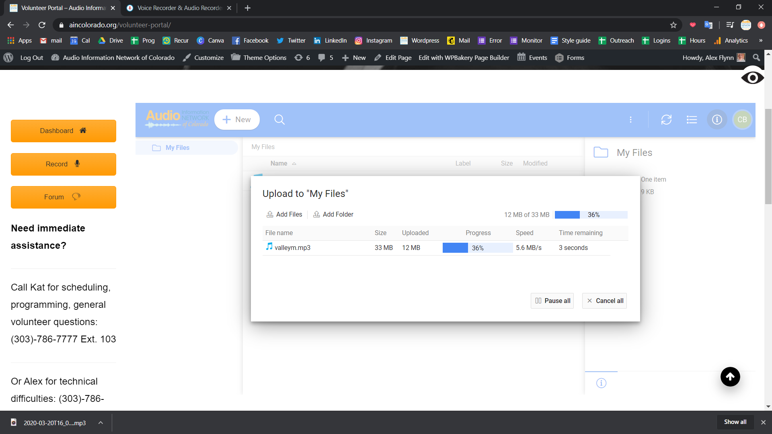

You will see your newly uploaded file listed.
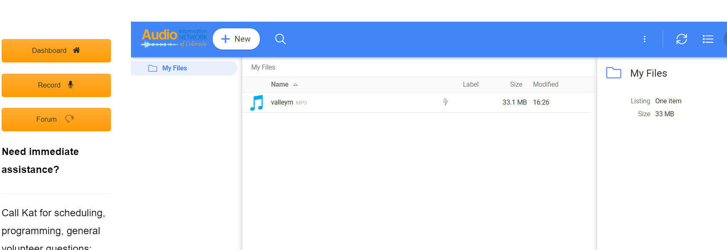
Your program may disapear from this list, and that is OK. That just means we are processing it or it is successfully in our systems.
- Log out. Click on your initials in the upper right corner and click “log out.”

