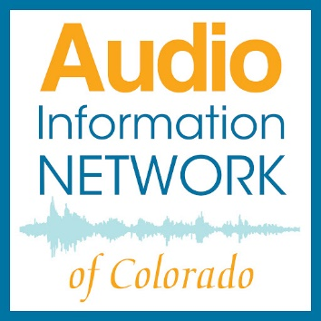
AUDIO INFORMATION NETWORK OF COLORADO
Studio Cleaning Protocol

Welcome to our studios, these steps are designed to keep you healthy and safe.
Because your health matters to us, we’re asking you to clean the studio when you enter AND when you leave to make sure things are as safe as possible.
*Disinfectant tip-let the items air dry for best results.
When you enter the studio:
- Carefully use the blue alcohol spray bottle to spritz the pop-filter.
- Use a disinfecting wipe to clean the keyboard, mouse, doorknob, and any other surfaces that seem like they’re touched often.
- Close the studio door when you’re recording.
Then again after using the studio:
- Use the alcohol spray to spritz the pop-filter.
- Use a fresh disinfecting wipe to clean the keyboard, mouse, doorknob, and any other surfaces you think you touched.
- You can also spray a quick spray of Lysol into the air, but not directed at any equipment.
When you exit the studio:
- Throw trash in the trashcan and put dirty dishes into the dishwasher, not the sink.
- Leave the studio door open and turn off the light.
- Leave all cleaning supplies in the studio.
Thank you! -The AINC Team

