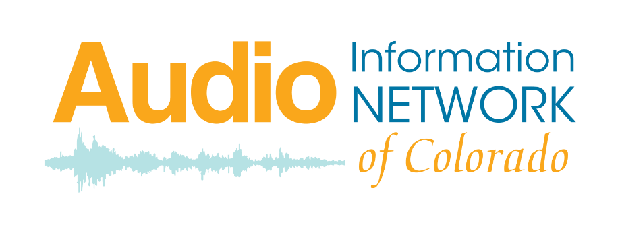

**Client Contribution Policy**

AINC does not charge listeners for services or equipment; however, listeners are given the opportunity to make a voluntary contribution. Announcements regarding contributions to AINC are made on the air, in FaceBook posts, and in program schedule, especially in the weeks leading up to Colorado Gives Day. Listeners are not required to contribute any amount but may be given information as to the costs of equipment, programming, or program schedules. For example:

* $20 will pay for a Braille program schedule.
* $50 will pay for an Amazon Echo Dot for a listener.
* $130 provides one hour of programming.
* $200 will pay for one listener digital receiver.
* $780 funds services for a listener for one year.

There is an opportunity for the contribution to be made in honor or in memory of a specific person.