AINC Partner Portal Navigation Basics
The AINC Partner Portal is intended to be central hub for organizations that have a partnership with AINC. You can find these helpful features on the Partner Portal:
- AINC equipment guides
- Printable documents and forms
- AINC policy information
- Listener Contact Tracking form
- “Report and Error” form
- The “Data Upload” portal where you can download and upload listener and other confidential information with AINC
- Other helpful links and resources for partners

*Not every feature in the portal will be relevant to your organization, depending on the partnership agreement.

To navigate to the Partner Portal, go to aincolorado.org and click “Partners” on the main menu.
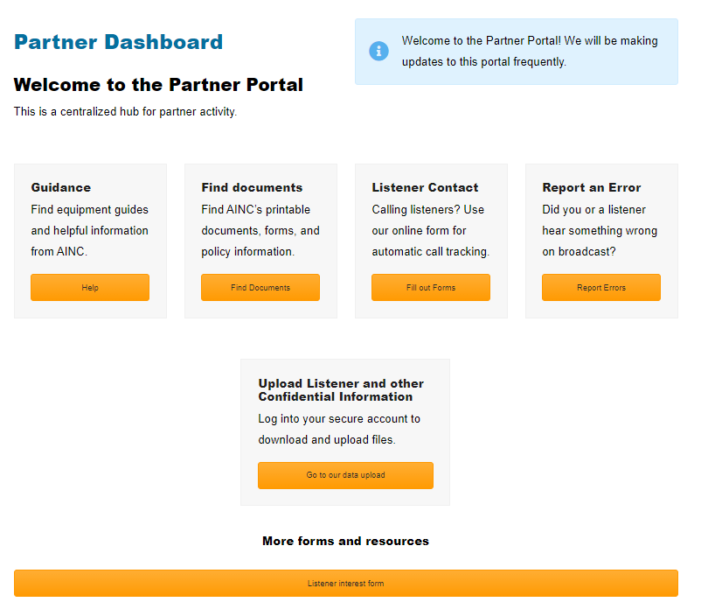
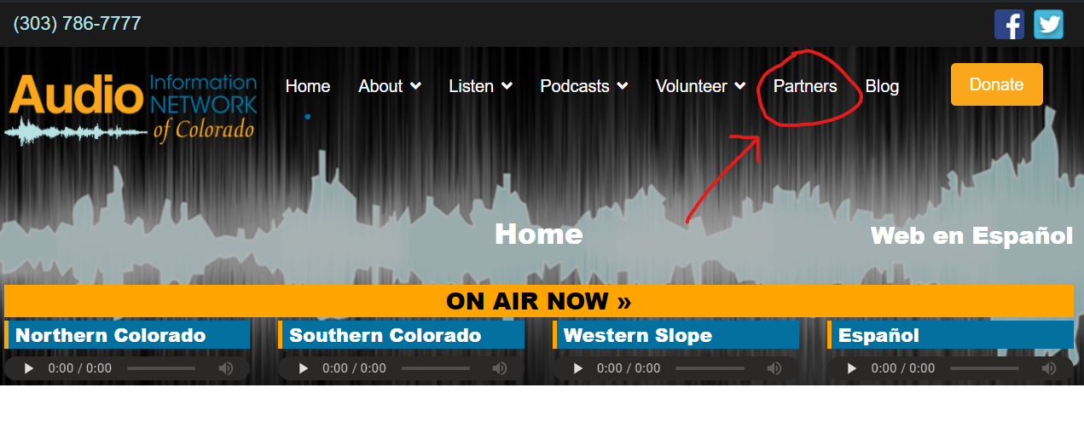

The Partner Portal Dashboard is the “home page” for the partner portal. Here is where you will navigate to other useful partner pages.

Here is an overview of what is contained in each section:
Guidance:
- Instructional videos and documentation for AINC equipment setup
  - Internet options (Amazon Echo and on our streams/ podcasts on our website)
  - Non-internet options (Digital Receiver and dial-in)
  - FAQ’s
Documents:
- Programming information and schedules
- Printable listener interest forms, consent forms, and other forms for AINC listeners.
- Outreach flyers
- AINC Policies
Listener Contact:
- For partnerships that include making contact with AINC listeners, this online form allows you to document your reassurance / listener follow-up calls.
Report an Error:
- Did you receive a complaint or concern from a listener? Document the error reported using this online form so we can make the fix and contact them if needed.
Upload Listener and other Confidential Information
- This is a secure username and password protected file-sharing area, where you can share confidential files between your organization and AINC. Files may include listener information or other documents. Your personalized account will be created by AINC upon partnership and your credentials communicated to you. What you have access to in your account will be unique to your organization, but here is an example of what it might look like.
